[Zichermann and Cunningham 2011] say that gamification is a term which may have different meanings depending on the context. According to [Deterding et al. 2011] Gamification refers to the use of design game technology or practices, game elements or game characteristics in non-game context.

[Huotari and Hamari 2011] define gamification as “a process of enhancing a service with affordances for gameful experiences in order to support user’s overall value creation”. They highlight that this definition does not mean that the gamification process has to be successful, gamification can only attempt to support the user in creating gameful experiences [Huotari and Hamari 2011].

For other point of view gamification may be considered a design process. [Salen and Zimmerman 2004] say that gamification can be a framework where participants are systematically motivated with targets. Following the definition of [Deterding et al. 2011], they highlight that game elements are difficult to specify

In Education, gamification has been used as a stimulation factor to instigate students to learn. Gamification in particular has been considered one of the key emergent and widely adopted teaching technologies in education [Alhammad and Moreno 2018, Johnson et al. 2016]. According to [de Almeida Souza et al. 2017], recent technologies have provided new opportunities for using games and their elements to enhance learning and student engagement.

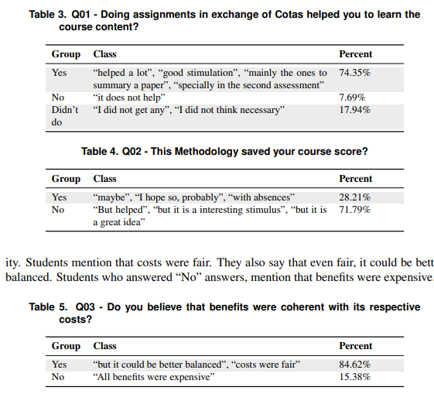

RQ01 - How Fhoment helps in learning? Based on the data collected during the case study, we say that Fhoment might be a helpful instrument to support learning. Considering the answers from questionnaire, some students said that most assignments helped them to study and learn the assessment contents. The idea of having a prize and this prize be used to obtain benefits in assessments, can stimulate students to do the assignments and by consequence, to learn and to fix the assessment contents.

RQ02 - How Fhoment helps to obtain better assessment result scores? As we also mentioned previously, a significant number of students would not be approved in the course but, due to benefits bought with Cotas they could obtain approval. We advocate that it does not mean that they were approved without learning, but in opposite, test assessments are not always fair, thus, this mechanism can help students to get extra points, once they needed to do assignments related to the assessment content to get this points.

RQ03 - There is coherence among assignments rewards, difficult degree and benefits cost? At last, we asked about the coherence among rewards, difficult degree and benefits cost. This question is important once, if there were not coherence, it could be a discouraging factor to keep using Fhoment Methodology. As we could analyze in case study, students said that there were coherence among these elements. Furthermore, the large majority of students would like to keep this methodology in the future